Project Design Phase-II
Data Flow Diagram & User Stories

Date | 6 july 2026
Team ID | XXXXXX
Project Name | Credit Card Auto Approval
Maximum Marks | 4 Marks

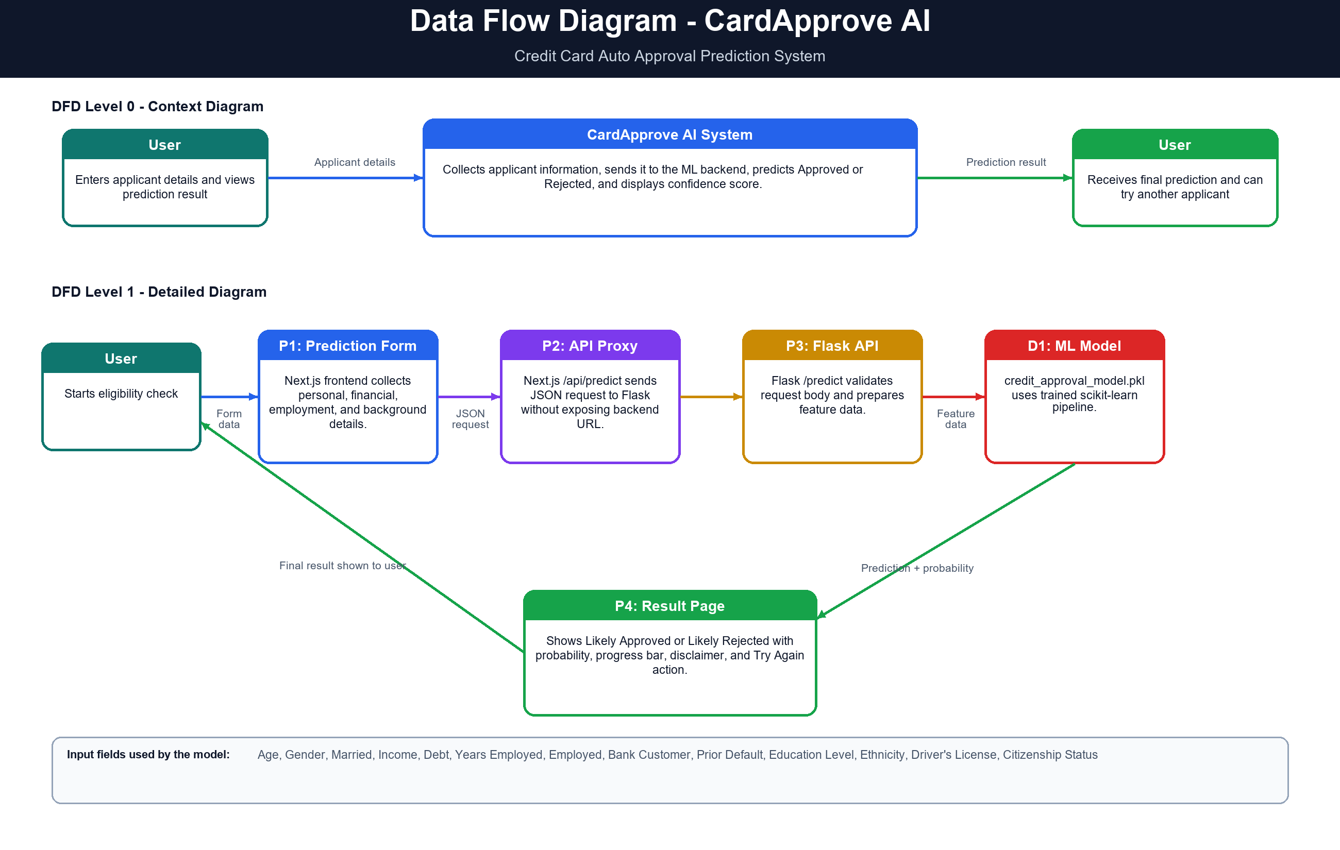
User Stories
Use the below template to list all the user stories for the product.

User Type | Functional Requirement | User Story Number | User Story / Task | Acceptance Criteria | Priority | Release
User | Application Navigation | USN-1 | As a user, I can open the CardApprove AI home page. | I can view the project purpose and navigate to prediction page. | High | Sprint-1
User | Prediction Form | USN-2 | As a user, I can enter applicant personal, financial, and employment details. | I can fill all required fields in the prediction form. | High | Sprint-1
User | Input Validation | USN-3 | As a user, I receive validation messages if required fields are missing or invalid. | The system shows errors for empty or incorrect inputs. | High | Sprint-1
User | Submit Prediction | USN-4 | As a user, I can submit applicant details for credit approval prediction. | The form sends data to /api/predict successfully. | High | Sprint-1
User | View Result | USN-5 | As a user, I can view whether the applicant is likely approved or rejected. | The result page displays Approved/Rejected and confidence score. | High | Sprint-1
User | Retry Prediction | USN-6 | As a user, I can try another prediction after viewing the result. | The Try Again button returns me to the prediction form. | Medium | Sprint-1
Developer | Backend Health Check | USN-7 | As a developer, I can check whether the Flask backend and ML model are available. | /health returns backend and model status. | Medium | Sprint-1
Developer | Deployment | USN-8 | As a developer, I can deploy frontend and backend separately. | Frontend runs on Vercel and Flask backend can run on Render. | Medium | Sprint-2
User | Fallback Handling | USN-9 | As a user, I can still receive a demo prediction if the backend is unavailable. | The app uses fallback prediction and shows demo mode. | Low | Sprint-2
User | Project Information | USN-10 | As a user, I can read about the model, dataset, and workflow. | About page explains ML workflow, tech stack, and features used. | Low | Sprint-2

